What do you do if you’re sick with the flu?
Even healthy people can get the flu. If you think you have the flu, or are suffering with flu-like symptoms, take these next steps:

- See your doctor for treatment.
Flu antiviral (prescription) drugs can treat your illness, shorten the time you are sick and help prevent serious complications.
- Stay home at least 24 hours
even after your fever is gone except to get medical care or other necessities
- While sick, limit contact with others
as much as possible to keep from infecting them
- Cover your coughs and sneezes with a tissue or your arm and help stop the spread of the flu.
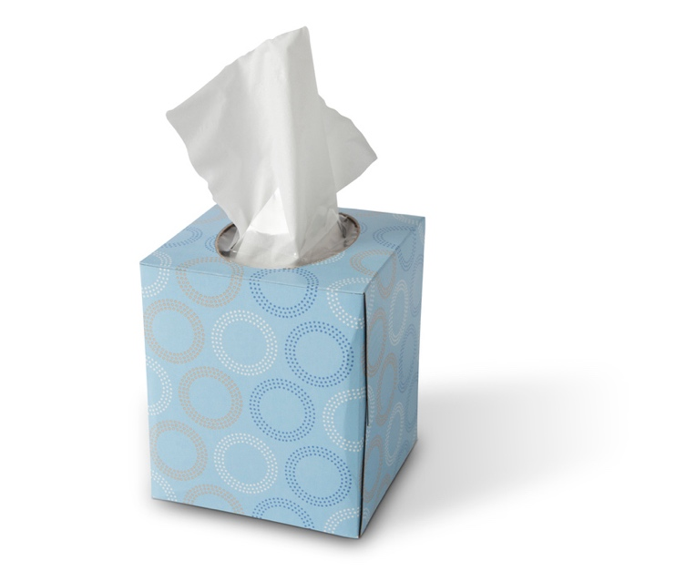
For more information and facts about the flu visit:
http://www.cdc.gov/flu/about/

