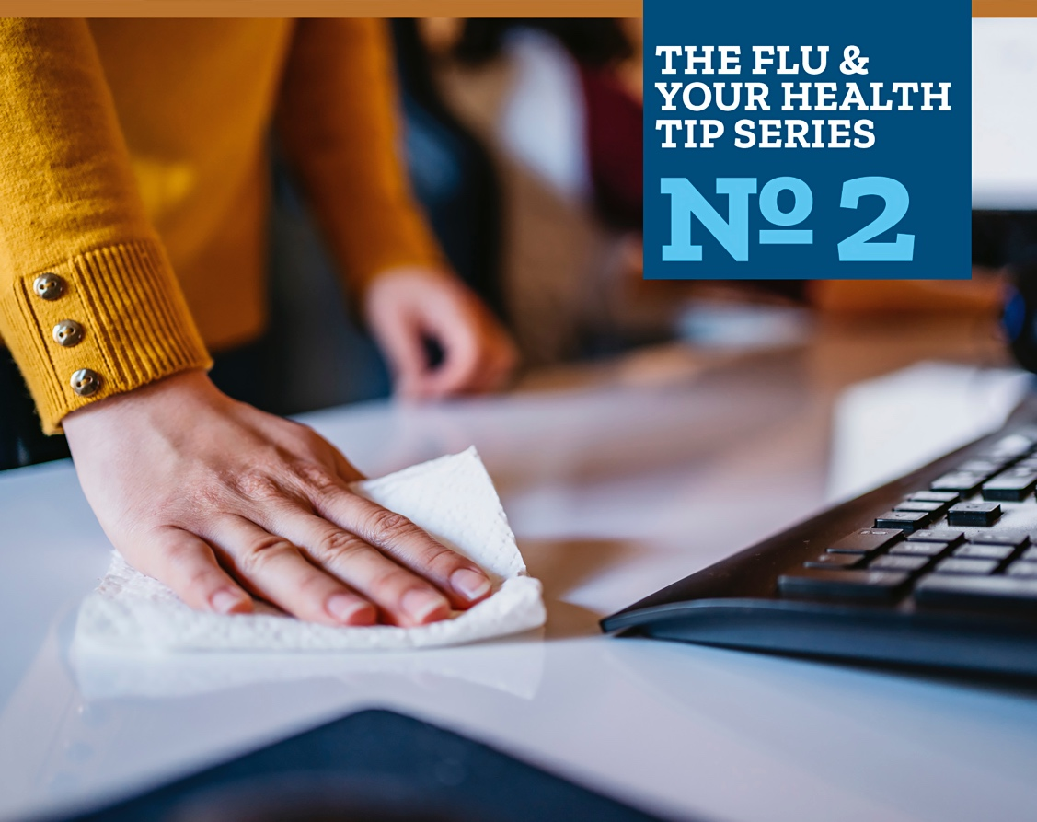
Practice Good Health Habits
Even healthy people can get the flu. Help stop the spread of germs and prevent respiratory illnesses by developing good health habits.

- Cover your cough with a tissue or your arm.

- Wash your hands often with soap and water for at least 20 seconds or use hand sanitizer.

- Avoid close contact with those who are sick. When you are sick keep your distance from others to protect them too.

- Keep your immune system working at its full potential:
• Drink plenty of fluids
• Eat nutritious foods
• Get plenty of sleep
• Be physically active
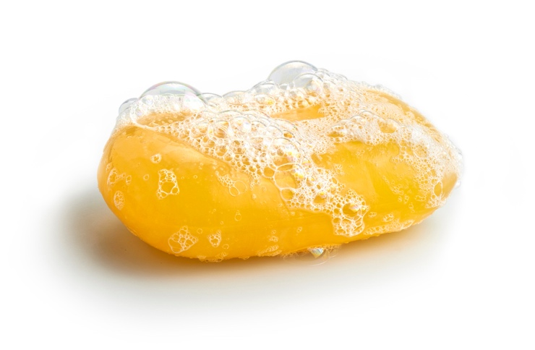
For more information and facts about the flu visit:
http://www.cdc.gov/flu/about/

