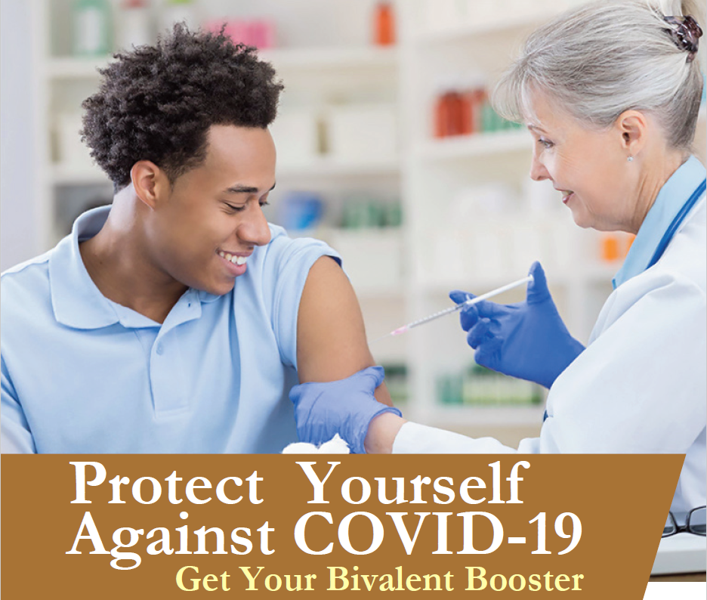

Getting a bivalent booster is the single best way to prevent COVID-19!

There are just [# days] more days until our free on-site COVID-19 bivalent booster vaccination program. This is your last chance to make an appointment for a convenient, on-site booster vaccination.

Date: [insert event date]
Time: [insert event start time-end time]
Location: [insert event location name]

Who is Eligible?
Individuals 18 years of age and older at least 2 months after either:

- Completion of primary vaccination with any authorized or approved monovalent COVID-19 vaccine, or
- Receipt of the most recent booster dose with any authorized or approved monovalent COVID-19 vaccine.

Individuals who have had a severe reaction to a COVID-19 vaccine dose in the past are not eligible to be vaccinated at these events.

How do I Participate?
To make an appointment, visit [insert registration link] or call Affiliated Physicians at 866-481-4391 from 8am to 6pm ET.

For more information, contact the Program Coordinator, [insert name] at [insert email], or call [insert phone].

