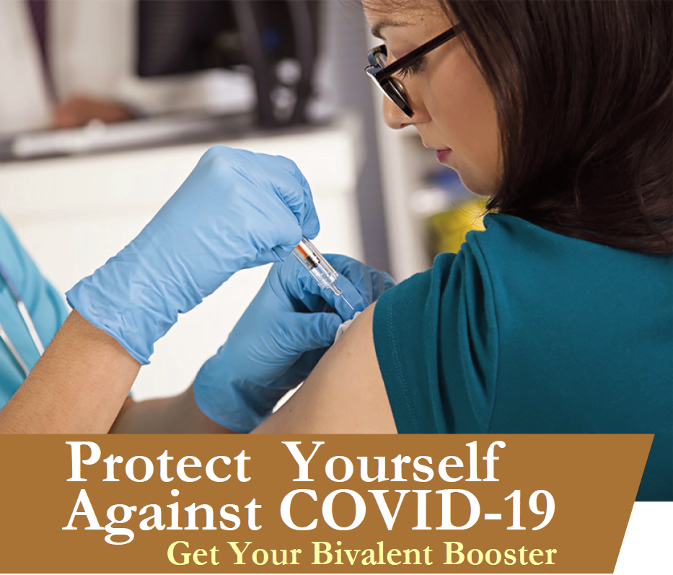

Sign up for your on-site bivalent booster vaccination today!

Although Omicron symptoms are similar to those of previous variants, it spreads more easily than earlier variants, including the Delta variant. Protect yourself and your loved ones from COVID-19 by getting your bivalent booster shot.

Date: [insert event date]
Time: [insert event start time-end time]
Location: [insert event location name]

Who is Eligible?
Individuals 18 years of age and older at least 2 months after either:

- Completion of primary vaccination with any authorized or approved monovalent COVID-19 vaccine, or
- Receipt of the most recent booster dose with any authorized or approved monovalent COVID-19 vaccine.

Individuals who have had a severe reaction to a COVID-19 vaccine dose in the past are not eligible to be vaccinated at these events.

How do I Participate?
To make an appointment, visit [insert registration link] or call Affiliated Physicians at 866-481-4391 from 8am to 6pm ET.

For more information, contact the Program Coordinator, [insert name] at [insert email], or call [insert phone].

