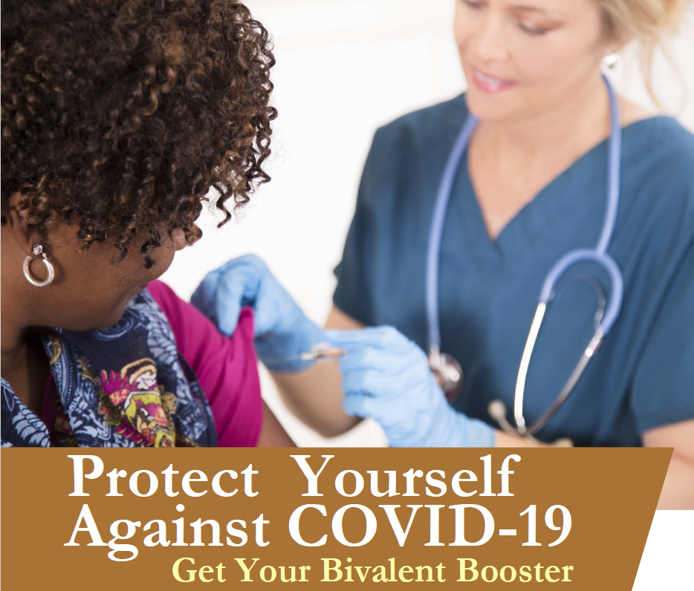

Free On-Site COVID-19
Bivalent Booster Program

We are excited to announce our COVID-19 bivalent booster vaccination program. COVID-19 bivalent booster vaccines are important because they protect against both the original virus and the Omicron variant BA.4 and BA.5.

Although Omicron symptoms are similar to those of previous variants, it spreads more easily than earlier variants, including the Delta variant. The Centers for Disease Control (CDC) recommends that all eligible people 5 years and older receive one updated (bivalent) booster.

It's becoming increasingly more apparent that when compared to doctors' offices, urgent care, and pharmacies — corporate offices may be the safest place to receive these critical vaccinations.

Date: [insert event date]
Time: [insert event start time-end time]
Location: [insert event location name]

Who is Eligible?
Individuals 18 years of age and older at least 2 months after either:

- Completion of primary vaccination with any authorized or approved monovalent COVID-19 vaccine, or
- Receipt of the most recent booster dose with any authorized or approved monovalent COVID-19 vaccine.

Individuals who have had a severe reaction to a COVID-19 vaccine dose in the past are not eligible to be vaccinated at these events.

How do I Participate?
To make an appointment, visit [insert registration link], or call Affiliated Physicians at 866-481-4391 from 8am to 6pm ET.

For more information, contact the Program Coordinator, [insert name] at [insert email], or call [insert phone].

