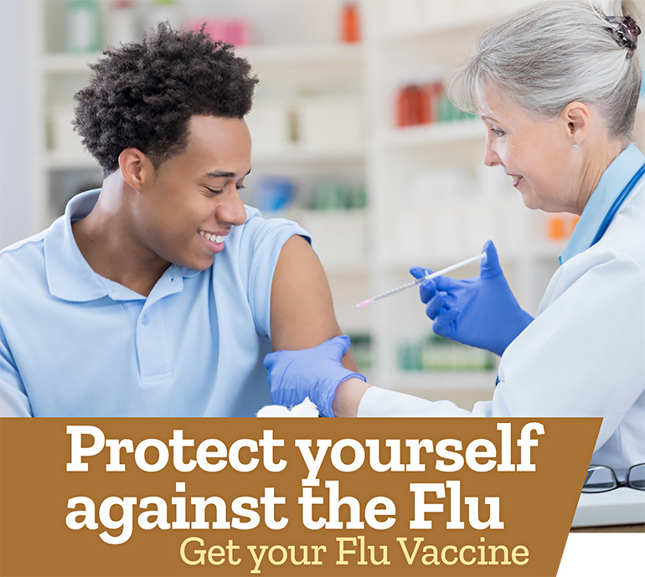

Getting a Flu Vaccine is the Single Best Way to Prevent Influenza!

There are just [insert days] more days until our free on-site flu vaccination program. If you’re interested in receiving a flu shot, you may still participate.

Date: [insert event date]
Time: [insert event start time – end time]
Location: [insert event location name]

Who is Eligible?
Flu shots are offered to all eligible [insert company name] employees. Please note:

- If you have a history of Guillain-Barré Syndrome, or have had allergic reaction(s) to prior influenza vaccines, you are not eligible for vaccination at this program. Please consult with your primary care provider.
- The CDC has updated its egg allergy guidance. People with an egg allergy, regardless of the severity of any past allergic reaction, are now eligible to receive a flu vaccination.

How do I Participate?
To make an appointment, visit [insert registration link] or call Affiliated Physicians at 866-481-4391 from 8am to 6pm ET.

For more information, contact the Flu Coordinator, [insert name] at [insert email], or call [insert phone].

