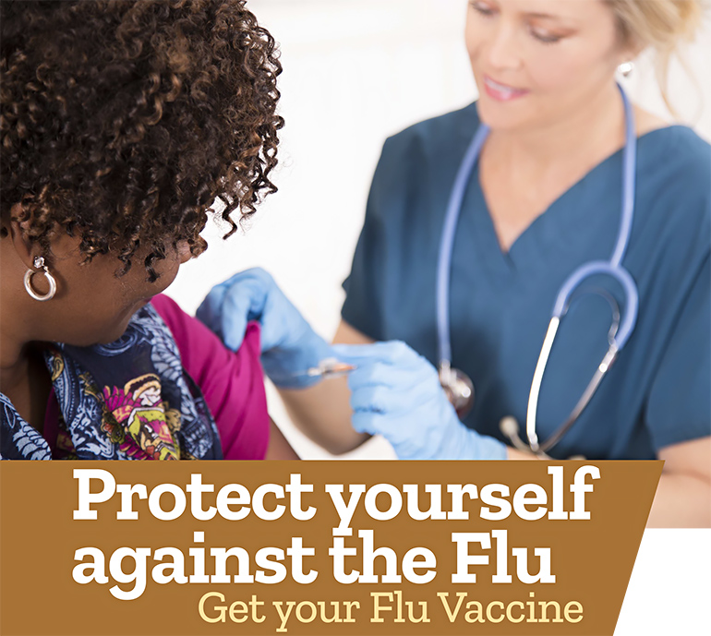

Free On-Site Flu Shot Program

We are excited to announce this year’s flu vaccination program. Each year in the U.S. more than 200,000 people are hospitalized and about 36,000 die of seasonal flu and flu complications.

With COVID-19 still a concern, flu vaccines remain extremely important to ensure optimal health. The Centers for Disease Control (CDC) recommends that everyone 6 months of age and older get a flu shot as the single best way to prevent the flu.

It's becoming increasingly more apparent that when compared to doctors' offices, urgent care, and pharmacies — corporate offices may be the safest place to receive these critical vaccinations.

Date: [insert event date]
Time: [insert event start time – end time]
Location: [insert event location name]

Who is Eligible?
Flu shots are offered to all eligible [insert company name] employees. Please note:

- If you have a history of Guillain-Barré Syndrome, or have had allergic reaction(s) to prior influenza vaccines, you are not eligible for vaccination at this program. Please consult with your primary care provider.
- The CDC has updated its egg allergy guidance. People with an egg allergy, regardless of the severity of any past allergic reaction, are now eligible to receive a flu vaccination.

How do I Participate?
To make an appointment, visit [insert registration link], or call Affiliated Physicians at 866-481-4391 from 8am to 6pm ET.

For more information, contact the Flu Coordinator, [insert name] at [insert email], or call [insert phone].

